Online Survey Questions

TITLE: Exploring University teachers’ design practice: Support resources for guiding course development

Researchers: Natasha Boškić, Stuart Sepp

The following questions have been formulated based on previous studies exploring university teachers’ design processes (see proposal for references).

Introduction

Thank you for agreeing to participating in this study, and for your time contributing to this project. Our aim is to explore university teachers’ course design practice, including their approach to online course design, the types of supports they engage and how they engage with them, along with the perceived value of a guided process supported by instructional or learning designers as well as perceptions of how sharing and using learning design visualizations can contribute to design work. In this offline survey, which should take around 45 minutes to an hour to complete, you’ll be asked a series of questions exploring how you engage in course design work. To submit anonymously, please visit https://ets.educ.ubc.ca/exploringteachersdesignpractice/ , or if you’d like to email directly, you can send to stoo.sepp@ubc.ca . Thank you for taking the time to participate.

Consent form for Participants

TITLE: Exploring University teachers’ design practice: Support resources for guiding course development

Who is conducting this study?
Principle Investigator:  Natasha Boškić, Ph.D.  Director of Learning Design, Educational Technology Support, Faculty of Education  Phone: 604.822.1831  Email: natasha.boskic@ubc.ca | Co-investigator:  Stuart Sepp, PhD  Learning Designer, Educational Technology Support, Faculty of Educationt  Phone: 604.827.489  Email: stoo.sepp@ubc.ca

Why are we conducting this study?

The aim of this study is to investigate how university teachers engage in online course design work as well as their perceptions of support resources in place to guide course development. Previous research in this area has indicated that instructors rely on a variety of sources of support, including workshops, self-paced resources, peer experiences. This study will explore teacher perceptions of common support resources that instructors engage with while working on course design. Participants will be selected based on their previous work engaging in online course design.

What are the benefits of participating?

While there may not be benefit to you specifically, what we learn about support resources for course design processes will help to inform a larger community of practice regarding how teachers engage in course design work, what is valuable to them, and how instructional support staff such as learning designers and instructional designers should best support this work.

How will this study be conducted?

If you volunteer to be included in this study, you will be asked to participate either in a semi-structured interview or to complete an online survey based on your preference for participating within one month of receiving this consent form. Both the survey and the interview serve the same purpose – to explore your experiences in the development of online courses and your perception of resources in place to support this work, including workshops, online documentation or instructional design staff.

Both the interview and the survey will take approximately 45 – 60 mins complete. The interview will be video or audio-recorded to allow for transcription and later analysis. Consenting to participate in the study also constitutes consent to be recorded (please see privacy section below for more on how your personal information and data will be protected).

To participate in this study, you have one month from receipt of this consent form to sign and return it to the researchers. You may return the signed form in hardcopy or electronic format to the researchers listed above.

How will the results of this study be shared?

Findings from the study may be published in academic journals, book chapters or conference presentations and proceedings. Results, including quotes from interviews or survey responses, will only be reported in ways that ensure the identity of participants remains confidential – video or audio recordings of interviews will not be shared in any capacity. Findings will also be used for other purposes, such as quality assurance within the Faculty of Education, and the internal UBC community.

Is there any way being in this study could be bad for you?

We do not anticipate any risks for you.

How will participant privacy will be protected?
Digital files, including digital video and audio recordings and de-identified data analysis files will be retained by the researchers for a minimum of 5 years as per UBC Policy #85. They will be stored on an encrypted USB drive and locked in a secure cabinet in a Faculty of Education office. Any hand-written field notes taken during interviews or focus groups will be locked in the same secure cabinet and the principle investigator will be responsible for the secure storage of all materials containing personal information.

Who can you contact if you have any questions about the study?
If you have any enquires about the research, you can contact Stuart Sepp (stoo.sepp@ubc.ca) and/or Dr. Natasha Boškić (natasha.boskic@ubc.ca).
Who can you contact if you have complaints or concerns about the study?
If you have any concerns or complaints about your rights as a research participant and/or your experiences while participating in this study, contact the Research Participant Complaint Line in the UBC Office of Research Ethics at 604-822-8598 or if long distance e-mail RSIL@ors.ubc.ca or call toll free 1-877-822-8598.

Participant consent and signature
Taking part in this study is entirely up to you. You have the right to refuse to participate in this study. If you decide to take part, you may choose to pull out of the study at any time without giving a reason and without any negative impact on your employment with UBC, professional reputation [for example, employment, class standing, access to further services from the community centre, day care, etc.].
By completing the questionnaire, you are consenting to participate in this research.

UBC ETHICS ID: H18-02631

Educational Experience
- Please describe your experience being a student in face-to-face courses.

- Please describe your experience teaching face-to-face courses.

- Please describe your experience being a student fully online courses.

- Please describe your experience teaching fully online courses.

- In which subject areas do you currently teach?

- In which subject areas have you taught in the past?

- Which course delivery methods (modalities) do you currently teach in?

- Which course delivery method have you taught in in the past?

- As a teacher, which course delivery method do you prefer?

Design Work
- Please describe the process you normally go through to develop your online courses including any steps do you go through, and your primary focus.

- What support resources do you connect with when engaging in course design work (e.g., Workshops, One on one sessions, literature, web resources)?

  - Do you engage with resources outside of your faculty or your institution? If so, which ones?

  - If you do not engage with workshops or human supports, what factors contributed to this lack of engagement? (i.e. why did you not engage?)

- How do you go about choosing technology tools or resources into your courses?

- What is your understanding of what an instructional designer or learning designer does?

- Have you previously worked with a learning or instructional designer while developing an online course?

If YES:
  - How did the instructional designer support your design work?

  - What are your thoughts on the approach taken by the instructional designer you worked with?

  - How beneficial did you find the instructional designers’ contribution to the overall process?

  - How has working with an instructional designer influenced the way you approach your own design process?

  - Will you transfer this process in any way to your course design work for face to face courses?

  - Would you recommend other university teachers work with an instructional designer?

If NO:
  - If you haven’t worked with an instructional designer, what factors contributed to this?

- Have you previously engaged with or seen examples of learning design visualizations? (examples below)

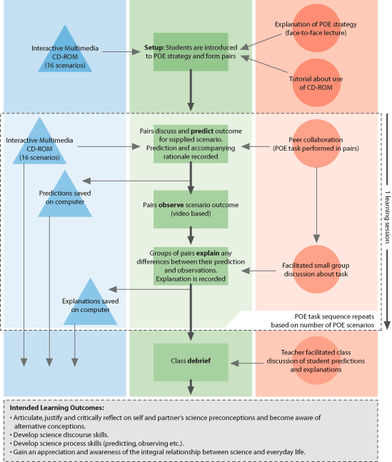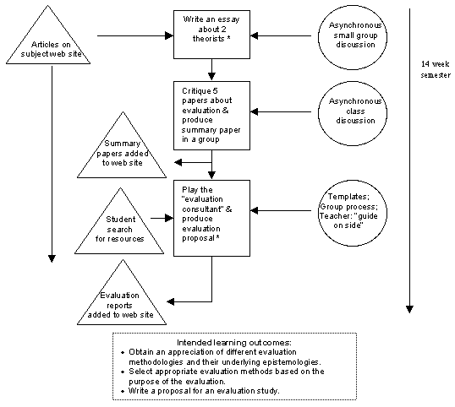
  - How valuable would the development of learning design visualizations be for sharing with other instructors?

  - How valuable would the development of these visualizations be for sharing with your students?

- How valuable would you find working with other instructors while engaged in your course design process?

  - Would you prefer more or less collaboration with other teachers in this work? Why?

