ETS Course Development Pilot Project Overview
Stoo Sepp 4/10/2018

1 Project Scope and Purpose

Supporting the development of online courses by Educational Technology Support (ETS) within the Faculty of Education has continually evolved over the years. As UBC transitions to a new online learning platform, one that features increased usability and therefore instructor capacity to create, manage and maintain their online learning spaces, the technical support needed to accomplish these tasks is anticipated to decrease. While still supporting technical needs within the new learning platform, it is also anticipated that the transition will afford new opportunities to explore more advanced pedagogical practice within the online teaching and learning space.
To facilitate this, a pilot project will be conducted from Summer 2018 that seeks to explore the effects of guided learning design processes for online course development. While still supporting the course developer and their needs, a number of ‘best practice’ activities based on widely established models of instructional design will be offered as part of a course development project. These steps are focused around building capacity within our academic staff in areas of instructional design including engaging in constructive alignment practices across a hierarchy of outcomes, building online communities through dialogic learning activities and designing authentic assessment tasks, while ensuring an active learning environment for all students.
The purpose of this project is to investigate instructor / course developer perceptions of the process to inform future practice, both in ETS and beyond. It also serves as a means to document a course development project to ensure milestones are being met, so a course can be delivered on time. Finally, literature has shown that in sharing visualizations of their created learning designs (see example below), academic staff can learn from this community of practice, improved methods for engaging and assessing their learners.
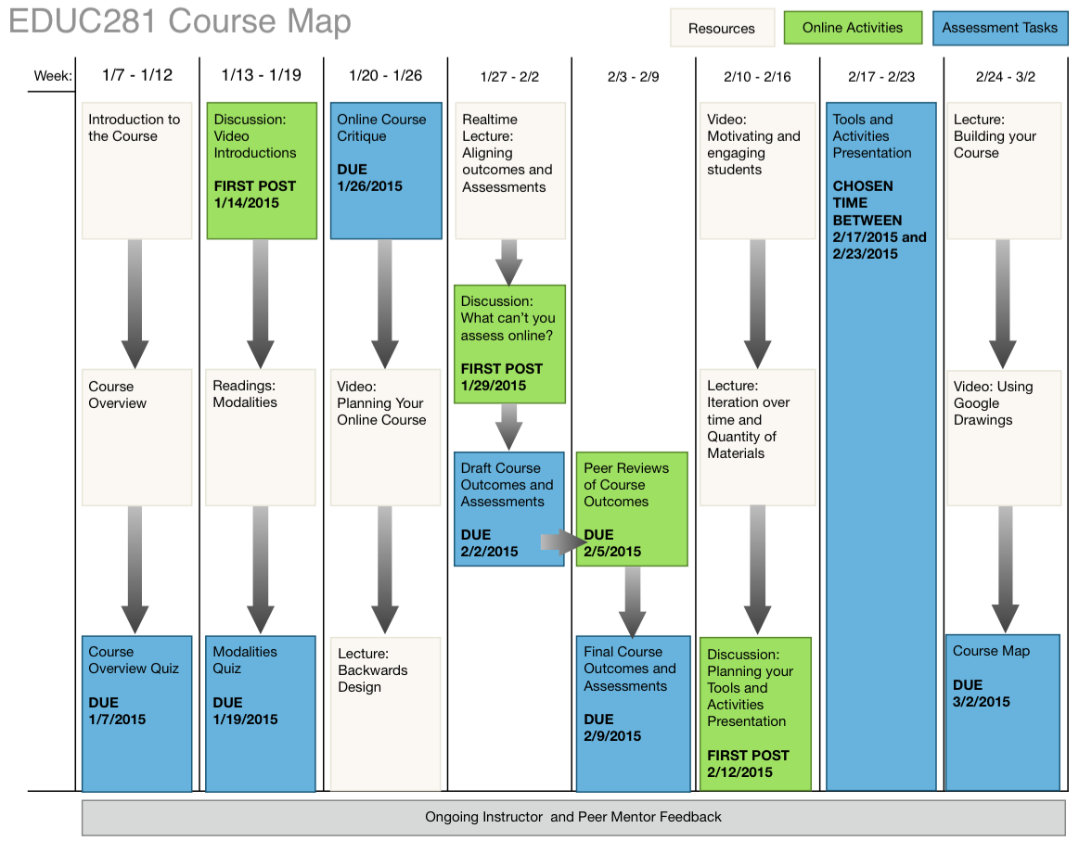
As part of this project, a timeline of two academic quarters for course development will remain in place, with specific meetings and milestones established with course developers along the way. Given that this pilot project is completely voluntary, it is important to offer options for engagement for course developers. The following section will outline these options and detail how each option will be facilitated.

1.2 Roles
Course developer (SME)
Formerly designated as a ‘Course Author’ or ‘Course Developer’, this faculty member or sessional instructor is the person hired by a department to complete the course development or revision work, including the course building within the primary online learning platform.
Instructional / Learning Designer (ID)
ETS staff member that serves as project manager for the Course Development project, as well as mentor to the course developer(s), providing scaffolded support in the areas of Learning Design the appropriate use of educational technologies, and training for the primary online learning platform.
Academic Reviewer
This faculty member is responsible for ensuring that outcomes, assessments and activities both align with program level outcomes and with other courses in the program. This also includes a review of course content to ensure it is appropriate for the curriculum and course level.

2 Engagement Options

2.1 Slight amendment of existing process
The first option would see the existing process retained to a large degree, with the only changes being a pre-established formal schedule of meetings between ETS staff and Course Authors across the span of the course development process, designed to ensure support throughout the project and to provide feedback on current progress. It is also recommended that as an agreement, course developers write any content directly into the Canvas VLE, moving away from providing word documents for upload. Text formatting, integration of supplemental technologies and setup of activities within the VLE would still fall within the scope of ETS staff support as part of the services provided.

2.2 Full Pilot Course Development Process
Moving from a paradigm of online course developers as authors of content towards architects of learning experiences, a number of changes to course development processes are required to facilitate creative and critical thinking surrounding outcomes, assessment, activities and content. As part of this revision, a focus on creation of content and activities within the LMS will still occur, however the process can include more guidance and scaffolding in areas of learning experience design.
Course developer(s) can be guided through a series of stages with the support of Instructional Designers (IDs) from ETS, which include activities with specific outcomes. These activities correspond to stages of course development such as:
- a reflection on learning outcomes including course and unit level outcomes;
- engaging in constructive alignment between content, activities, formative and summative assessments, course outcomes and program outcomes;
- appropriate choice of learning technologies;
- becoming familiar with ETS/external quality standards;
- identifying opportunities to collect feedback from learners; and of course, becoming proficient with the online learning platform.

Each activity would require set meeting times to work through and support, with milestones associated with delivery of specific artefacts related to each activity (e.g. revised outcomes, developed unit outcomes, activity, and content sourcing ideas).
Each of these activities require time and resources, so it is important that their benefit is fully explained to any course architect undertaking a project. Documentation including any worksheets, documents or other materials intended to support a project will be available at any time, so that the process is transparent to those who wish to engage in it. In addition, timelines for this process must take into account the learning experience design aspects, and adjust milestones accordingly, while still allowing sufficient time to build out the course in the online learning platform.
By supporting academic staff in these activities, a body of evidence will emerge in the form of worksheets, meeting minutes, revised outcomes and other resources which document the process of course development from start to finish, from identifying learning outcomes to a final learning design artefact, all of which can be used to demonstrate benefit and share with other instructors both in the Faculty of Education and externally.

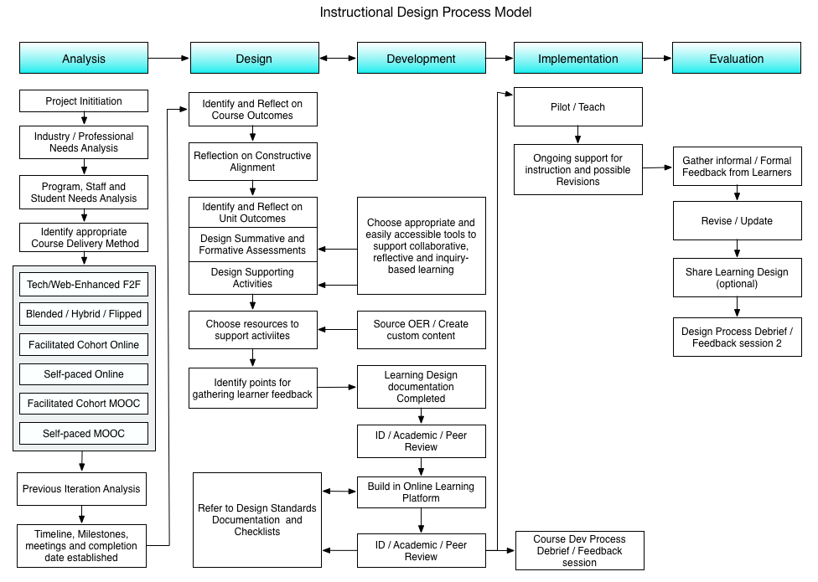
Figure 1: Flow chart of proposed instructional design process based on ADDIE model.

2.3 A Menu of services
While the ideal scenario is that all course developers will engage in the full process outlined above, there may be some factors that do not allow for their full engagement. In this case, ETS would offer a ‘menu’ of services, representing a spectrum from the basic process to the full one, in which course developers can pick and choose which items they would like assistance with. If a course developer chooses this option, ETS can then document the items chosen and any reasons for leaving certain activities out.
Once menu items have been chosen, the same establishment of milestones will take place, with regular meetings to support each item to ensure a timely delivery of the course, again building in sufficient time for building out the course within the online learning platform.

In the next section an outline of key meetings for the Full Pilot Course Development Process option are presented, along with specifics on what each meeting entails.

3 Key Meetings

Introductory meeting (30 mins – 1 hr)
The first meeting would introduce the project, along with its aim of piloting a new process for course development using the ADDIE instructional design model along with design methodologies found in the literature. The process would then be outlined, placing emphasis on a constructive alignment methodology, a process of critically examining course level outcomes, unit level outcomes, formative and summative assessment tasks and learning activities to build upon and co-reinforce each other, informing decision making and ensuring valid and reliable measures for learning are in place supported by engaging learning experiences. Examples will then be provided showing previous course designs after going through a similar process, along with details on what constructive alignment looks like in practice.
Next, the steps involved in the process will be outlined along with a discussion of what each step entails, as well as the presented option to only engage in the steps they choose. Lastly, time is allowed for a potential course developer(s) to ask questions about timing, technology use and other issues.
Lastly, if a course developer(s) has chosen either to engage in the full process or have chosen which steps they would like to engage in, a timeline, including next meetings, deliverables and completion dates would be established. If a course developer(s) need time for reflection, a next meeting is scheduled one to two weeks later, where full timelines will be established.

Post Meeting Activities:
- course developer(s) decide on level of engagement
- course developer(s) will work on draft of course learning outcomes.
- Instructional Designer will provide feedback on previous iteration of course, if present.

Course Learning Design Meeting (90mins – 2 hrs)
This working meeting is intended to allow instructional designers and course developer(s)s to work together to develop a basic learning design for the course, including the list of course and unit outcomes, formative and summative assessment strategies and activities. It should be noted that at this time, discussion of specific technologies is not presented, but a focus placed more on desired learning experiences and outcomes for the students with any appropriate supporting technology types discussed in general.
Before the meeting the course developer(s) will have been provided with guiding questions on outcomes and asked to draft some revised outcomes for discussion. Over the first part of the meeting instructional designers will work with the course developer(s) to further iterate the learning outcomes, including a discussion of how they align with program outcomes, how they may be measured, how easy they are for students to understand, and the levels to which students will master them.
Once course outcomes are finalized, unit outcomes will then be drafted, along with summative assessments to gather evidence for their mastery. At this point summative and formative assessments, along with supporting activities will be drafted, highlighting the relationships between these factors and how they promote student engagement and critical and reflective thinking. Throughout this process, supporting technologies will be discussed in general terms, with specifics of implementation addressed in the course building process. Finally, generally identifying some sources of content and how they can prepare students for activities and assessments will be integrated into the design along with opportunities for gathering student feedback at the beginning and the end of the course will be explored.
Throughout this process, a visual learning design representation of the course will emerge which will articulate the major milestones, and the students’ pathway through the course from start to finish. This will serve as the learning design artefact for the course and will be developed and designed jointly between the instructional designer and the course developer(s).

Artefacts:
- Draft Course Outcomes
- Final Course and Unit Outcomes
- Alignment of Assessments with outcomes matrix
- Visualization of Learning Design diagram / flow chart / document

Post Meeting Activities:
- ETS will create final version of Learning Design diagram for embedding in the course and framing the course build.

Finalizing Learning Design – (1hr – 90mins) – OPTIONAL
If final learning design representation is not created in draft form by the end of the last meeting, or if course developer(s)s would like more time to reflect on their work so far, this meeting can serve to finalize the creation of that artefact. In addition, this meeting can also serve as an opportunity to explore specific technologies chosen to support the class, such as webinar, video creation or collaboration software.

----- COURSE BUILDING PHASE -----

Orientation to Learning environments and technologies (90 mins – 2 hours) - OPTIONAL
If required, course developer(s)s will engage in a brief orientation to the primary online learning platform as well as other supporting technologies, how they work and how students will be using them. This workshop will also cover the units and departments that provide support for these technologies both within the Faculty of Education and in the larger UBC community.

Additional meetings as needed to support course building

Design Process Debrief and Interview (30 mins – 1hr)
To gather feedback on this project, it is important to collect information on its effectiveness in terms of professional development and course development support offered by ETS. A short interview to support the project will be conducted by an instructional designer with the course developer(s)s involved in the project to record their perceptions of the process itself, what they gained from it, how it differed from their previous work in developing courses, how they may see it improved for the future and whether they would recommend it for their colleagues.

4 Professional Development Gains
As part of this pilot project, the course developers or instructors will be supported through a guided instructional design process intended to build their capacity in undertaking instructional design methods in a more independent manner. This building of capacity, along with a built-in mechanism for sharing visualizations of learning designs (see Figure 2) with their fellow instructors will open these projects up to be seen by others within the faculty. In addition, involving other instructors in the course evaluation process (having them complete a checklist with feedback) will also build their capacity in critical assessment of certain design methods and practices.

5 Documentation
After the 1 - 2 year project is complete, data collected including interviews, surveys and in other produced artefacts will be collected and analyzed qualitatively. Trends and common themes will be addressed and articulated to inform future practice for ETS services, along with a revision of the process if need be. A written report for internal use will be produced, outlining the project’s scope, sequence, benefits and challenges along with key findings and finalized recommendations.
As the project will be run as a descriptive case study, an article will also be written to document the process along with academic staff perceptions for publication. As such, BREB approval will be sought for approval in June 2018 and research ethics materials created to support the pending application.

Companion Documents
- Appendix 1: Course Development Plan (Forthcoming)
- Appendix 2: Course Development Process (descriptive)
- Appendix 3: Course Development Checklist
- Appendix 4: Designing for Learning Documentation (including worksheets, research questions and interview questions)
- Appendix 5: ‘Designing for Learning’ electronic resources (Forthcoming on ETS website)

