A Model for the Designing for Learning Process
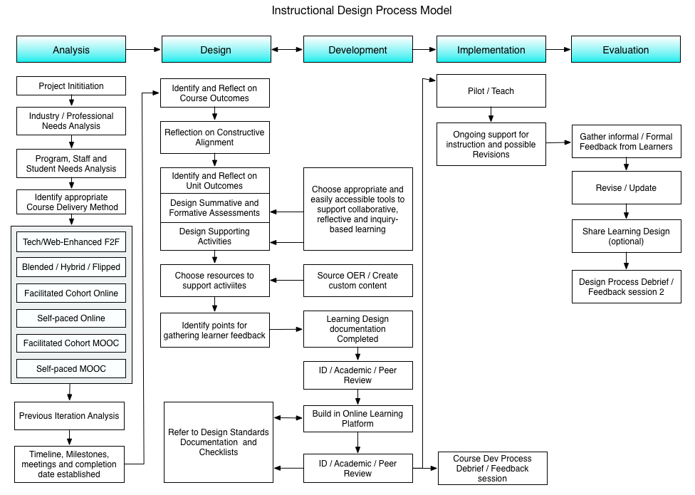
Recommendations for Course Administration Practice
This model represents a transition towards a systematic process for course development, which embeds reflective practice and professional development for academic staff within the Faculty of Education at UBC. As a predicate to outlining this process, an important logistical and human resources issue should first be addressed.
It is a given that the design and eventual delivery of any technology-enabled learning experience is dependent on the instructor who is delivering it.
For example, if an online course developer and the course’s assigned instructor have a different level of experience with technology and/or a different comfort level with online facilitation practices, this misalignment between course design and facilitation may result challenges for students which may impact their success in the course. As such, the following is recommended:
- For a single course, it is important that course developers engaging in this process be one of the final instructors, given that learning designs, including the development of assessments, learning activities and content delivery will be guided by individual experience teaching online and face to face, technical expertise and preferred teaching approaches. If a course developer cannot be the instructor, the instructor should be consulted about how certain outcomes can be achieved within the scope of their own comfort level with technology and teaching preferences.
- For a course which has a course coordinator with multiple instructors teaching different sections, it is recommended that these individuals form a team (with the coordinator as team lead), ensuring that all stakeholders provide input into the future of the course design, technologies used, and the final student learning experience. In this case, outcomes and assessments can be developed by one or all participants in this working group, but a level of flexibility with technologies used and online pedagogical practices should be accounted for to ensure that all teachers are comfortable teaching based on their level of expertise.
An example in which this misalignment may present a challenge is presented below:
A course developer has vast experience with multiple educational technologies, and has been teaching online for 15 years, with expertise in building online communities of practice and facilitating real-time online meetings. They develop a great course and hand it off to the instructor, however the instructor has only been teaching online for 6 months and has limited experience using educational technologies or facilitating online activities, which are featured heavily in the designed course. This misalignment between the experiences of the course developer and the instructor may lead to unintended challenges for students, and possibly impact their learning experiences and success in the course.

While staffing and resources are at the discretion of the initiating department for course revisions, this is presented merely as a point of consideration for those planning and overseeing future course development within the Faculty of Education.

Analysis
The first step in the instructional design process is to try to understand the scope of the project and what it will entail.
  - Project Initiation
This stage usually is where the project starts, whether by identification from the ETS or by school / faculty.

  - Industry / Professional Needs Analysis
Before the course can be transitioned to an online learning experience, the school / faculty and staff there should conduct an analysis of current needs and trends in their sector to ensure students will be best prepared for the workforce. This should include specific job-related skills, as well as soft skills often overlooked when designing curriculum. Note that this step is usually performed by PDCE or the initiating department.

  - Program, staff and Student Needs Analysis
Next is an assessment of the course, staff and student needs for the project. The most ideal online learning experience is one where students move through together in a cohort (see 1.4.3 below), engaging with each other, as well as the content, guided through the experience by a qualified online instructor, but this may not always be a realistic option for a project. Students may be living in rural areas where broadband internet is not available, serving in self-defence forces where access to the internet is limited, or simply currently on an internship somewhere. Instructors may have heavy workload for on-campus courses, may have never taught online, or may be unfamiliar with certain required technologies. The project leaders in the faculty may also have predetermined thoughts on how to the project should be offered to students. In such cases, it will be up to ETS staff to work with project stakeholders to ensure the best learning experiences for students, based on these factors. Note that this step may be performed by PDCE or the initiating department in conjunction with ETS.

  - Identify Appropriate Course Delivery Method
Based on the factors above, there are different of courses that can be offered online, each with their own pedagogical tools and approaches that would be appropriate. See more for each type of course below.

    - Tech/Web-Enhanced F2F
Tech-enhanced face to face course is traditional face to face on-campus course offering, with in-class technology enhancements. This involves integrating technology to support classroom activities, with no online resources used to support content delivery or course administration / communication. Note that using educational technologies in the classroom alone is quite rare in contemporary learning contexts, so most courses will combine pedagogical elements and tools from Tech-enhanced and Web-enhanced courses.
A Web-enhanced face to face course is also a traditional face to face, on campus course offering, but with online (as opposed to in-class) enhancements. Typically, this involves posting online resources, online assessment task submissions and support mechanisms such as discussion forums. Web-Enhanced classes importantly do not displace classroom contact time, like a Blended / Hybrid / Flipped Course does, so any activities provided online should be either optional or have minimal time impacts on the student.
    - Blended / Hybrid / Flipped
This is a course in which a considerable amount of face-to-face contact time reserved for learning activities is displaced and moved online. There is not set percentage or amount required, but typically a hybrid or blended course would range from 20% online to 80% online, depending on pedagogical necessity. A key factor in the design of blended courses is that the online and face to face activities presented work interdependently to form a cohesive learning experience for the student across domains. One example may be that if a student does not engage in an online activity, their ability to complete subsequent face to face activities or assessments will be impaired. Overall, blended courses should not just be a collection resources posted online which students passively engage with, but an active learning experience that alternates between the online and classroom learning spaces.
    - Facilitated Online
A fully online class that promotes learner engagement through collaborative learning communities is one in which all students engage in the same activities at roughly the same time either asynchronously or synchronously. Just as face to face students gather in a classroom or lecture theatre with an instructor, learning about and engaging with a specific topic, online students should be doing the same, but with a more flexibility of engagement. As opposed to a face to face course in which students are expected to attend at set hours during the week, students in Facilitated Online courses should be free to engage in learning activities across multiple days or weeks, while ensuring that all students are engaging in the same activity together.
    - Self-Paced Online
Sometimes it is necessary for students to move through a course at their own pace, where collaboration and learning communities are perhaps not the best way of completing the learning outcomes for the course. These types of courses may, for example, involve becoming familiar with state or national standards in a particular domain, or may involve working with individual instructors on capstone or research projects. In this case, it is important to allow flexibility in the learning experience, but wherever possible, build in opportunities for student engagement where possible.
    - Facilitated MOOC
Much like a Facilitated Cohort Online, the MOOC version is simply on a larger scale. Learning and Instructional designs may differ based on the Course Learning Outcomes, so a variety of approaches and tools may be appropriate for a larger student count. Activities that foster student support and interaction are highly encouraged as it is unlikely the instructor will be able to support every student individually.
    - Self-Paced MOOC
Unlike the Self-Paced Online, the MOOC version should lend better for collaboration and student interaction, given that there is usually a larger student count. Building collaborative activities and assessments that allow student to student support mechanisms are common good practice within a self-paced MOOC.
  - Previous iteration analysis
If the Project involves Courses and Courses that are not new, at this point it is useful to assess a path moving forward based on the existing learning and instructional design for the courses. With the course type chosen, along with the needs of industry, students and academic staff, ETS staff can compare and contrast the existing offerings with what will be required to complete the project and deliver the revised version to students.

  - Timeline, Milestones, Resources and completion date established
Given the above, completion dates, required resources (both financial and human), milestones, responsibilities and other project details should be articulated in writing and agreed to by all parties.

Design
The design phase should focus on the offline planning of the learning and teaching experience. A focus on how learners move through the course whether in sequence or a non-learner fashion, along with the support they receive and the information they encounter is the end goal of this phase. Of course, the tools used within the online learning platform will play a role in this design, based on certain affordances presented by the technology available, but this should be the only role it plays. ETS staff should be aware of available tools and the affordances those tools present pedagogically, but should design courses based on the learning experience and only use tools to support those experiences.
  - Identify and Reflect on Course Outcomes
Course outcomes may already exist for the current project. Nevertheless, it is always useful to examine these outcomes as they are important for informing assessment design and subsequent learning activity design. Many course learning outcomes or course learning outcomes may not speak to skills in the workplace, but simply describe what the student will do for the instructor. If this is the case, it is important to revisit and revise where appropriate to ensure student readiness for professional practice.

  - Identify and Reflect on Unit Outcomes.
Part of building an aligned learning experience is to break up CLOs into more manageable chunks within the course, which take the form of Unit Learning Outcomes (ULOs), which will guide the design of formative assessments, activities and content needed to support the completion of summative assessments.
  - Plan Summative Assessments
Now that CLOs and ULOs have been established, the next step is to design assessments, both formative and summative. Summative assessments should provide evidence of the mastery of each CLO (or aligned CLO) and formative assessments should provide opportunities for students to process novel information and skills as part of the learning experience. Both Formative and Summative Assessments are highly encouraged to be thought of as learning experiences, with opportunities for reflection, peer feedback and other mechanisms, as opposed to a singular courseive judgement of performance. Summative Assessments, for example, do not always need to focus on the creation of a singular artefact, but can be a collection of collaborative, formative and creative learning experiences for the student.

  - Develop Formative Activities
Once all formative and summative assessments have been designed, the next step is to design the experiences that will allow students to process novel information and skills in preparation for providing evidence that they have mastered these skills. Note that this section, along with the following section are often completed in tandem, with learning materials chosen as learning activities are designed. It important to distinguish, however, that learning materials such as textbooks should not drive the design of learning activities, but the opposite. Appropriate resources should support activities and experiences.

  - Choose Learning Materials to support Formative Activities
Usually concurrent with the previous stage in this process, resources should be chosen to expose learners to new information, concepts and processes so they may be easily processed, critically analyzed and applied in learning activities, formative and summative assessments. The type of resources chosen and / or created is always up to the instructor, though it is encouraged to use existing shared resources, or to create sharable resources for others to use.

  - Reflection on Constructive Alignment
In accordance with Constructive Alignment practices, it is important to align Course Learning Outcomes (CLOs) with Program Learning Outcomes (PLOs), and where possible assess PLOs within appropriate courses. Mapping these outcomes and providing evidence of the completion of this mapping will provide evidence of this important work. For each individual course, it is important also to reflect on the alignment between unit learning outcomes and course learning outcomes as well as the assessments, activities, content that supports learners in their demonstration of these outcomes. Note that this work may be completed by PDCE or initiating departments in conjunction with ETS.

Development
This phase involves the creation of the course within the chosen online learning platforms. It should ideally be completed after the Design phase, as building courses within the online platform may negatively impact learning experience design. Ensuring that the learning experience of the student is the primary focus means that the affordances of technology tools support designed learning experiences, instead of technology tools influencing learning experiences. This is a delicate balance to walk, so ETS staff should simply be mindful of these two approaches.
  - Choose appropriate and easily accessible tools to support collaborative learning
Based on the learning design established, appropriate and easily accessible tools should be selected to support collaboration within the course to fulfill the needs of assessment tasks and learning activities. This phase may be partially completed with phases 2.4 and 2.5, but it is encouraged to not build the course in the online platform as these decisions are being made, due to the possible negative impact on student learning experience.

  - Source OER or create custom content
If the course requires the creation of custom content, an instructional designer can assist with this creation, if this creation is deemed appropriate, cost-effective and pedagogically necessary. Alternative materials may already exist, so it is encouraged to explore Open Educational Resources and other materials that may accomplish the same pedagogical goals. Please also be aware, that more OER is able to be ‘remixed’, meaning that if it is not perfect, it can be adapted to suit the needs of the project.
  - Identify points for gathering learner feedback
Now that the course has been largely designed, it is important to identify places where learner feedback can be gathered during the first offering of the course, along with how this feedback can inform revisions and future learning design or instructional practice.

  - Visualization of Course Learning Design completed
Once all instructional and learning design has been completed, a course map or timeline should be created that serves as an outline for the student experience within the course, including their linear or non-linear pathway through the course, any materials they may encounter and all activities and assessments they may engage with.
  - Peer / Instructional Designer Review
After the learning design is completed, an initial review will be conducted by peers and/or IDs with feedback provided before the course is built in the online learning platform.
  - Build in Online Platform
Once the course learning designs are completed, the course should then be built in the chosen online learning platforms including support mechanisms, informal feedback mechanisms and other orbiting requirements. Course should be tested for usability and accessibility, and finally, checked for established quality standards. Also ensure that all tools used function properly for students and any activities or materials with access limitations are tested and functional.
  - Refer to Course Quality and Design Standards
As the course is being developed on its chosen online learning platform, the course builder, along with the instructional designer supporting the project will refer to course quality and design standards to ensure the course meets usability, accessibility and copyright standards and practices, along with best practices in building community and engaging learners.
  - Peer / Instructional Designer Review
After the course is finished being built, if there are other course developers willing, peer review using an course quality checklist will provide further insights into how the course can be designed to ensure the above. If requested, or if no other course developers are willing, the supporting instructional designer will complete a course review.
  - Design Process Debrief / Feedback session
At this point in the project, feedback from the course developer will be gathered by the instructional designer in the form of a qualitative survey and interview. A discussion of what worked and what didn’t will be included so as to guide future practice in supporting further course development.

Implementation
Now that the course / course has been built in the online learning platform, it is time to deliver the course
  - Pilot / Teach the Course
With the ongoing support of ETS staff, the course is facilitated by the instructor. A place will be provided within the online course for the instructor to provide keep a record within the online course (using hidden content) of any pedagogical or technical issues encountered, which will inform evaluation and subsequent
  - Ongoing Support for Instruction and Possible Revisions
It is possible that changes to course in the learning platform may need to be made on based on initial learner feedback, so continued support and professional development will be provided by ETS during the initial offering.

Evaluation
Now that the course has been delivered to students, it’s time to gain feedback, revise and share it, if that is part of the project’s goals.
  - Gather informal / Formal Feedback
During each offering of the project’s courses, at least 2 informal surveys should be built into the learning design such that feedback is collected which will inform the improvement of the course. The first survey should focus on usability and ease of access to materials and activities and should be collected 2-3 weeks into the course. This will provide useful feedback and may drive minor structural and tool revisions. A final informal survey should be delivered nearer to the end of the course, concurrently or before formal course evaluations are administered. The purpose of this final survey is to gain more summative feedback from students, regarding their learning experiences, and any suggestions they may have for improvement.

  - Revise and/or Update Course
Based on the above feedback, before the next offering of the course, revisions to the course should be completed in the form of an updated learning design and implemented in the online learning platform.

  - Share (Optional)
If part of the project is to share the course as Open Courseware, materials as Open Textbooks or OER, or adaptation to a MOOC platform, this can be done after revisions are made.
  - Design Process Debrief / Feedback session 2
Finally, after the course has been taught and feedback from learners gathered, feedback from the course developer and/or instructor will be gathered by the instructional designer in the form of a qualitative survey and interview. A discussion of what worked and what didn’t will be included so as to guide further changes in the process.

