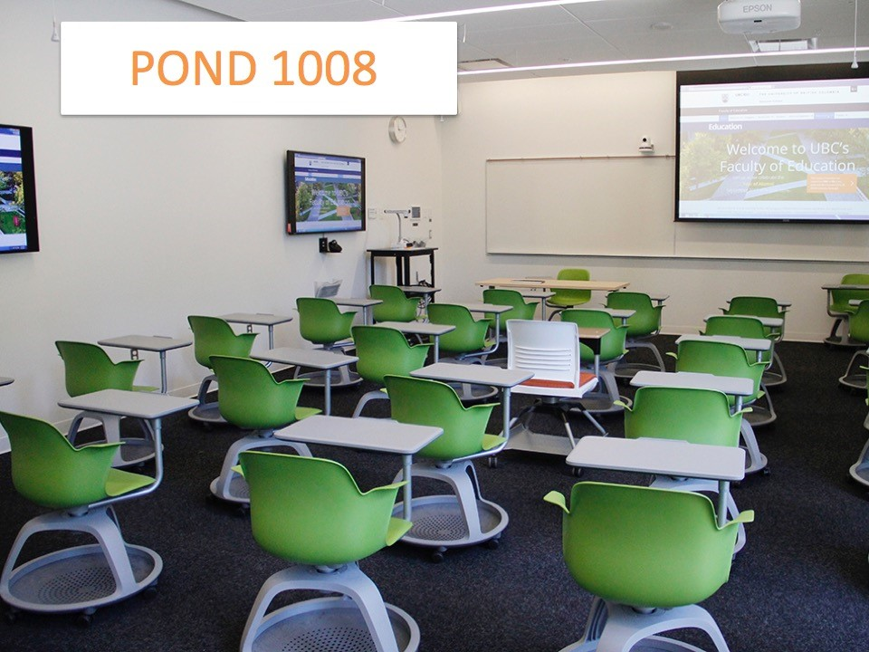

At a Glance: Ponderosa 1008
- Moveable seating for 24 people
- Four “break-out” stations distributed around the room, each equipped with a TV, a camera, and microphones
- Content can be pushed to all or a specific breakout station TV and vice versa.
- Document camera can display information to all the TVs in the room.

Potential uses

- Invite guest speakers
- Allow students to attend a class remotely
- Deliver online info sessions
- Host virtual office hours

room access
- Book this room through Scheduling Services https://forms.students.ubc.ca/scheduling/room-booking
- This classroom is not locked and should be accessible at any time.

USING web/video conference in THIS ROOM
- The equipment is software agnostic, but is most suitable for BlueJeans or Skype.
- The BlueJeans login information is outlined on the laminated info sheet in this room.

support
Contact AV Helpdesk if you require training, technical support during the session, or if you need a video conference session recorded. UBC AV can be reached at av.helpdesk@ubc.ca or 604.822.7956. Mon - Fri 7:30 am - 8:00 pm.

