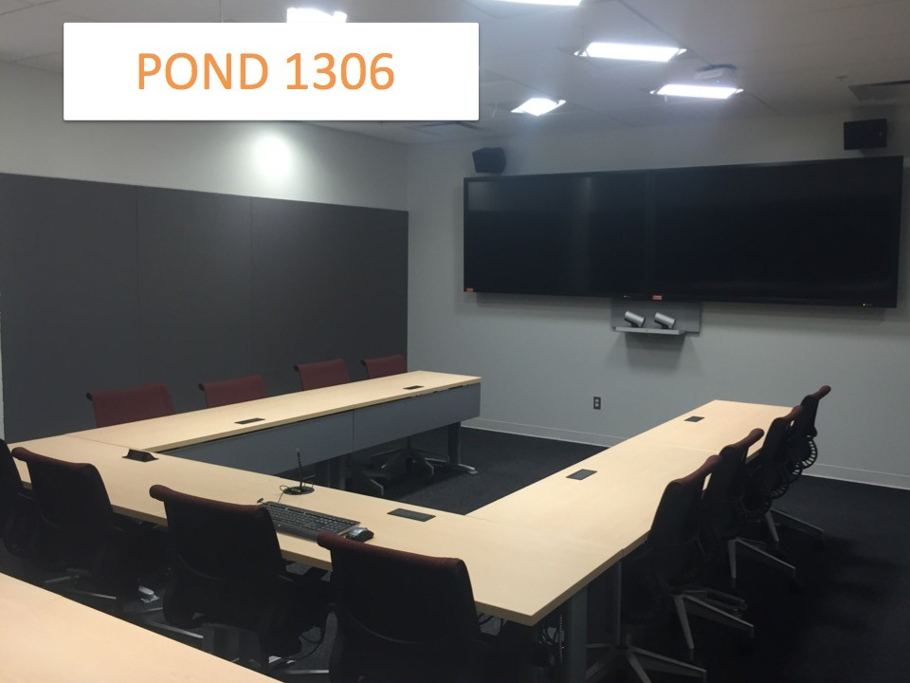

At a glance: Ponderosa 1306
- Tiered Panel-style seating for 18 people
- Automatically activated built-in microphones
- Front-of-room cameras automatically track speaking participants
- Secure access – card reader

potential uses

- Invite guest speakers
- Allow students to attend a class remotely
- Deliver online info sessions
- Host virtual office hours

room access
- Must be booked on the Education internal booking system. See authorized staff in your department to book this facility.
- If you have booked this room during regular office hours (Mon - Fri 8:30am - 4:30pm), you will need to sign out an access card, available at Ponderosa in the LLED office (#2013) or EDST office (#2009). You may also sign out a card available in your department in Scarfe. There is a replacement fee of $10.00 if a card is lost/not returned.
- If you have booked this room Mon – Fri 4:30pm - 8:00pm and need AV support, see below (“Support”).

USING web/video conference in THIS ROOM
- The equipment is software agnostic, but is most suitable for BlueJeans or Skype.
- The BlueJeans login information is outlined on the laminated info sheet in this room.

support
For training, technical support during your session, or if you need a video conference session recorded:
Submit a ticket to UBC IT-AV Services at http://it.ubc.ca/sos or contact the UBC AV Helpdesk: av.helpdesk@ubc.ca or 604.822.7956. Mon - Fri 7:30 am - 8:00 pm.

